Maths Language

Name these shapes

Match the words to the clocks

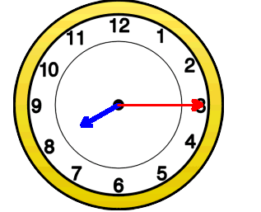
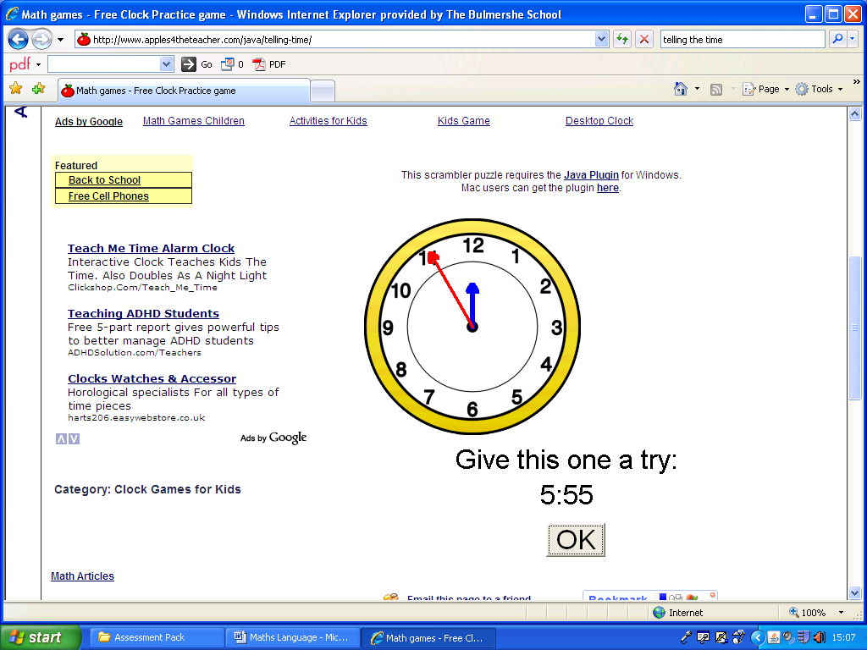
5 to 12

Quarter past 8

8 o’ clock

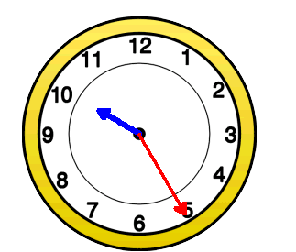
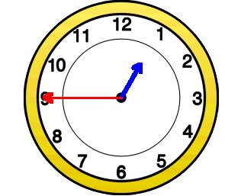
Quarter to 1

9.40

25 minutes past 9

