

Reading task 2

**Tom's House**

This is Tom. He is six.

Tom went to the shop with his mum. His mum was in the shop for a long time. So Tom went out. He wanted to go home.

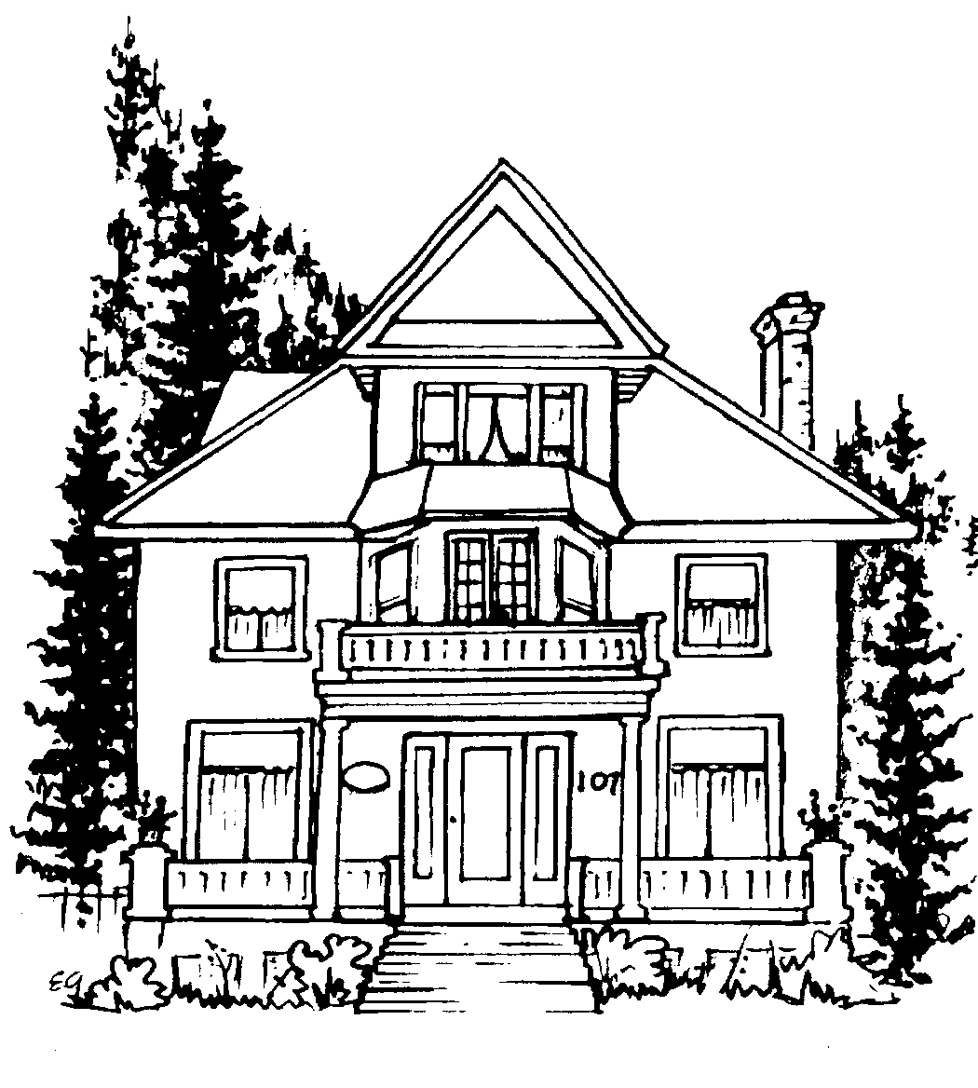

Tom walked down the road. He came to a big house. It was not his house. He walked on down the road. He came to a little house. It was not his house.

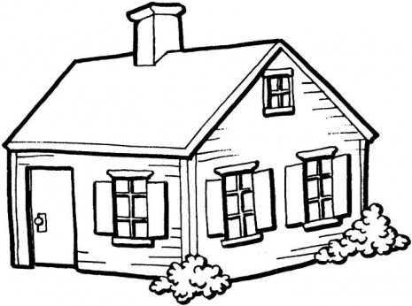

He walked on down the road. He did not see his house. He was lost.

Questions:

1. How old is Tom?
2. Where did Tom go with his mum?
3. Why did Tom leave the shop?
4. What will happen next?