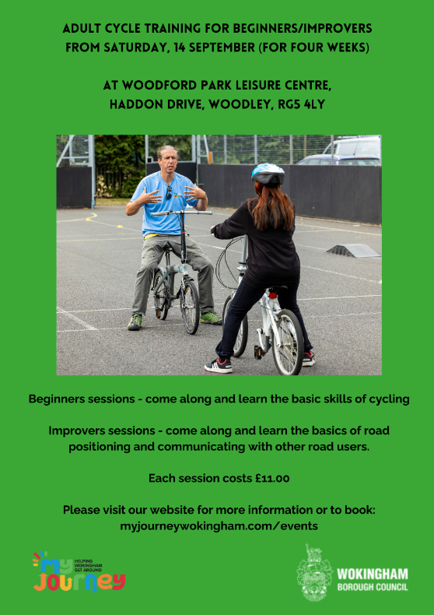

Adult Cycle Training
Have you thought how nice it would be to have a family cycle ride around a park or local Greenway but are put off because you cannot cycle or cannot cycle with confidence? Have you felt that you’d like to cycle more but are worried about cycling on the Roads?
We can help with our Adult Cycle Training; we have two levels of courses to help you enjoy the fun and social benefits of cycling.
Our Beginner sessions aim to help you learn to ride a bike and to build confidence by developing your cycling skills. After that why not try our Improvers session to help build confidence cycling on the road.
Cycling is a great way to increase your exercise. It is social, non-load bearing, fun and gets you out in fresh air. It can be a great family activity, so why not give it ago.

