**Adding text to PDF document**

1) Select the ‘fill in forms field icon on the left hand side of the PDF

2) Click on the area you want to add text to create a text box and type directly into this

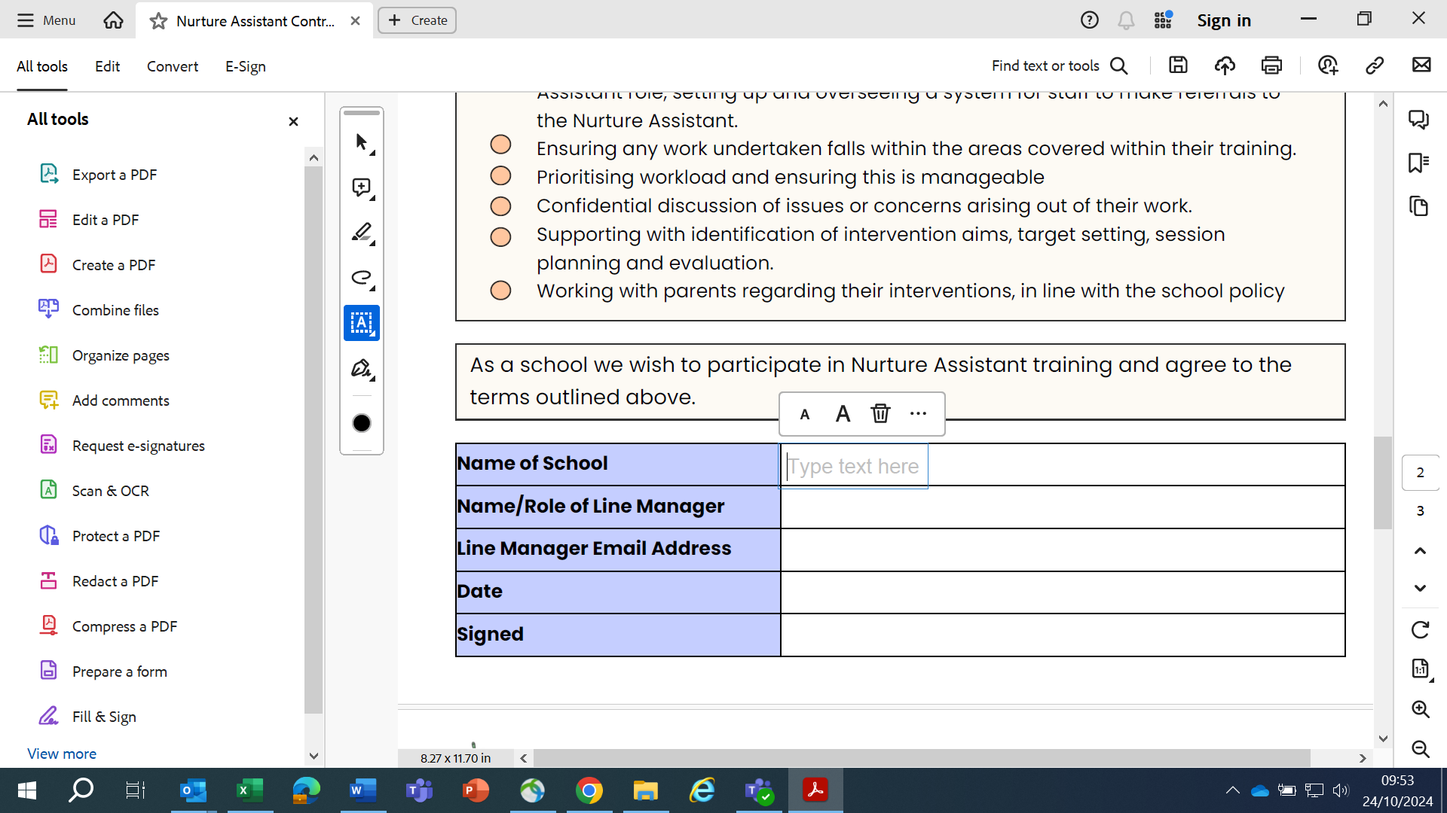

3) Once all fields are completed save the document with a new name