Dear Headteacher
Prevent and Channel Update -Autumn 2024
Keeping Safe On-Line
The violent disorder over the summer in some parts of the country after the tragic attack at a Southport dance studio was fuelled by the spread of extreme right-wing narrative mainly using social media. Young people are almost certain to see extremist content on-line whether they seek it out or not.
The latest media report in 2024 from Ofcom highlights numerous facts about children's online safety such as nearly a third (31%) of 8-17-year-old children who game online say they chat with strangers while gaming.
This comes from the studies Ofcom has carried out about children's entertainment-related experiences and activities: from social media platforms to video games and TV. See the report in full here:
Children and Parents Media Use and Attitudes Report Ofcom 2024
This is a useful reminder of the need to raise awareness with students and families about keeping safe on-line. The NSPCC have extensive on-line resources including a free recorded webinar for parents, please share this via your newsletters and social media:
Keeping children safe online | NSPCC
Annual Cybersurvey
Thinking about how well we are doing to help children and teenagers manage their online lives, develop critical thinking and a readiness for adulthood in a digital world. One way to consider this, is to gather their views and measure their experiences.
The ‘Cybersurvey’ annually explores the online lives of young people. It has run since 2008 and now includes an adapted version for children aged 8-11.
It will open for 2024 in October and remain open until mid-December, giving schools several weeks to complete it.
Anonymity is provided for both schools and children. It is run in a partnership between Adrienne Katz of Youthworks Consulting and Dr Aiman El Asam an associate professor of psychology at Kingston University.
To read the most recent reports, please visit www.thecybersurvey.co.uk or choose one to suit you:
Secondary school teens ‘Real or Fake?
Primary ages 8-11 ’Fun, Friends, Fears & Fallacies’

If your school is interested, please read the Invitation and FAQs on the home page and fill in the Sign In form for safeguarding reasons. They will send you details of how to access the survey and your school’s unique code.
Digital and Technology Standards
I wanted to remind you as well of the standards schools need to meet to reduce the risk of cyber-attacks and to prevent access to malicious sites as part of our efforts to keep young people safe.
Find out what standards your school should meet on cyber security and user accounts:
Meeting digital and technology standards in schools and colleges - Cyber security standards for schools and colleges - Guidance - GOV.UK (www.gov.uk)
Prevent Referrals| Assessing Risk
The Prevent Programme is designed to safeguard anyone who may be susceptible to all forms of extremism or radicalisation. The aim is to act early to spot the warning signs of someone being drawn or groomed into extremist ideologies to provide support via the multi-agency Channel Panel.
The government has produced guidance to help you consider risk indicators. These risk indicators are a helpful guide to help you make a judgement on the appropriate response. Click on the link below to access this guidance. If in doubt, make a referral.
Managing risk of radicalisation in your education setting - GOV.UK (www.gov.uk)
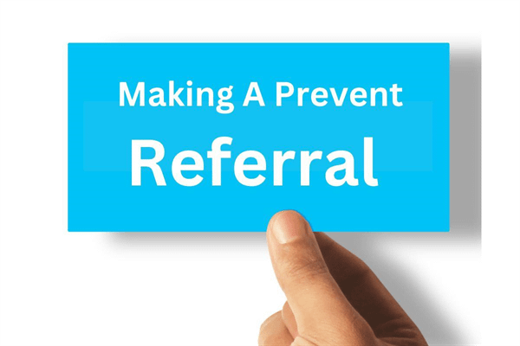
How to report concerns and make referrals to Channel about a child or adult at risk of extremism​:
NB Concerns about a child or an adult should always be made to either children’s or adult’s social care as appropriate as well as reporting to Thames Valley police by completing the Prevent referral form.
You can click on this link to the Berkshire West Children’s Safeguarding Partnership here for information about making a referral including access to the Prevent national referral form.
https://www.berkshirewestsafeguardingchildrenpartnership.org.uk/scp/professionals/prevent-1
If you need to make a referral for a young person aged 18 or over, please find the information on the Berkshire West Adults Safeguarding Partnership website:

https://sabberkshirewest.co.uk/practitioners/prevent

The role of schools is key in safeguarding young people from harmful content on-line. Thank you for all the work you are doing in raising concerns and making appropriate Prevent referrals.

I hope this is helpful and if you have any questions, please get in touch with either myself or Zoe Hanim.

Best Wishes
Lorna Pearce
Chair Wokingham Channel Panel lorna.pearce@wokingham.gov.uk
Prevent and Channel lead: Zoe Hanim zoe.hanim@wokingham.gov.uk

