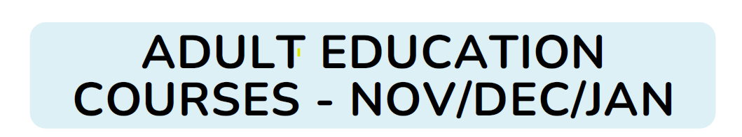
Christmas might be jingling its way in but hold onto your sleigh bells! The Adult Education Team have a sleigh-full of courses ready to go in the coming weeks!
Whether you prefer cosying up online or coming along in-person, we've got a feast of learning goodies for everyone.
Up and coming courses include:
Family Learning – Managing Child Anxiety, Understanding Teenage Anxiety and Building your Child’s Resilience.
Maths Courses – Courses aimed at parents include Help your child with maths, Introduction to Reception and KS1 Maths, Introduction to KS2 Maths, Mixing up Maths, Terrific Timestables, Fun with Time and Sensory Maths.
Other maths courses aimed at improving your maths skills for life and work Excel at Budgeting, Help with your Maths, Love Food Hate Waste, Maths for ESOL and Maths for the Workplace.
Skills for Work – Confidence skills to get back into work or volunteering, Design and format a CV using Word, Introduction to being a Teaching Assistant and roles in schools, Introduction to working in the NHS and Care.
Digital Skills – Creating and Delivering presentations, Excel for Beginners, First Steps in iPads and the Internet.
Some of our courses are free and others may carry a small fee (some concessions apply).

