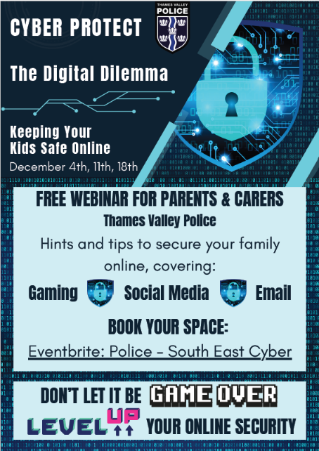
THE DIGITAL DILEMMA: Keeping Your Kids Safe Online
Thames Valley Police Cyber Protect are running a free webinar to help parents and carers understand some of the risks young people face online, and how they can best protect themselves and their family from falling victim to cyber criminal behaviours!
Covering social media, gaming and emails, this webinar will give you tips and tricks to help you protect them in today’s online world.

The webinar is running three times over the next few weeks, and tickets are available here:

https://www.eventbrite.co.uk/o/police-south-east-cyber-77121396093
Reserve your space today!

