Dear Headteacher
Prevent and Channel Update -Spring 2025
Wokingham Keep Safe Campaign February 2025 | online safety
To tie in with Safer Internet Day 11 February 2025, ‘Involve Community Services’ and Wokingham’s ‘Community Safety Partnership’ invite you to a special webinar to launch a month - long safety awareness campaign on Monday 3 February, 4:00 to 5:30pm.
This campaign is dedicated to promoting safety for all our residents through a series of engaging events throughout February. The launch webinar will highlight online events throughout February focusing on online safety for young and vulnerable people with links to keeping safe in the physical world.
Click on the link to ‘Involve Community Services’ dedicated page:
Keep Safe In Wokingham - Involve Community Services
Register for the launch and webinars of interest to you. A number of the webinars are dedicated to Parents and Carers so please highlight those via your newsletters home.
Safer Internet Day encourages safe online technology use, particularly for children and young people. In the UK, educators and caregivers can access free resources created by online safety experts to incorporate into classrooms. These resources include lesson plans and activities aimed at teaching young people essential skills for navigating the digital world securely. Schools participating in Safer Internet Day can empower students to use the internet responsibly and wisely
Free Resources for Safer Internet Day provided by UK Safer Internet Centre

Click here to access the resources
Incels - a guide for those teaching Year 10 and above
Educate against hate have developed a guide that explains what the Incel online subculture is and the signs that a young person may be engaging with it. This guide is for teachers of key stage 4 and older students.
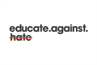Click here to access the guide

Prevent Referrals| Assessing Risk| a reminder
The Prevent Programme is designed to safeguard anyone who may be susceptible to all forms of extremism or radicalisation. The aim is to act early to spot the warning signs of someone being drawn or groomed into extremist ideologies to provide support via the multi-agency Channel Panel.
The government has produced guidance to help you consider risk indicators. These risk indicators are a helpful guide to help you make a judgement on the appropriate response. Click on the link below to access this guidance. If in doubt, make a referral.
Managing risk of radicalisation in your education setting - GOV.UK (www.gov.uk)
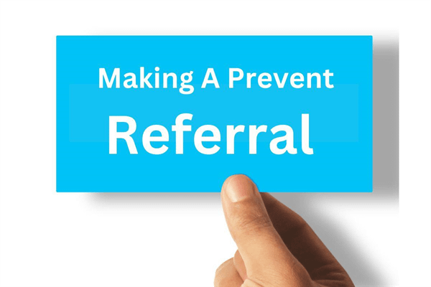
How to report concerns and make referrals to Channel about a child or adult at risk of extremism​:
NB Concerns about a child or an adult should always be made to either children’s or adult’s social care as appropriate as well as reporting to Thames Valley police by completing the Prevent referral form.
You can click on this link to the Berkshire West Children’s Safeguarding Partnership here for information about making a referral including access to the Prevent national referral form.
https://www.berkshirewestsafeguardingchildrenpartnership.org.uk/scp/professionals/prevent-1
If you need to make a referral for a young person aged 18 or over, please find the information on the Berkshire West Adults Safeguarding Partnership website:

https://sabberkshirewest.co.uk/practitioners/prevent

The role of schools is key in safeguarding young people from harmful content on-line.

Thank you for all the work you are doing in raising concerns and making appropriate Prevent referrals.

I hope this is helpful and if you have any questions, please contact either myself or Zoe Hanim.

Best Wishes
Estelle Kelleway
Chair Wokingham Channel Panel estelle.kelleway@wokingham.gov.uk
Prevent and Channel Lead: Zoe Hanim zoe.hanim@wokingham.gov.uk

