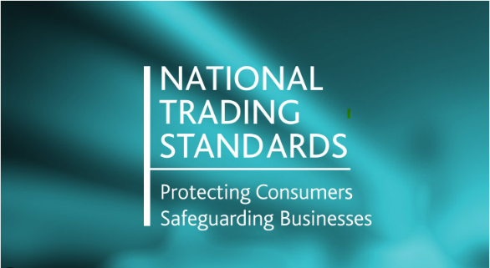
TRADING STANDARDS NEEDS YOUR HELP
Trading Standards Officers routinely carry out undercover purchasing of age restricted products, such as vapes, fireworks and alcohol across Wokingham Borough. The work is undertaken jointly with the Licensing Team and Officers from the Public Protection Partnership.
We need to recruit volunteers (aged 15-17) to assist with this work, which will take place out of school hours throughout the year and be conducted under Officer supervision.
Many volunteers use the work they do with us to assist them in finding part time jobs or as part of their DoE Awards. We also provide references for College and University applications.
If you know of any young people who may wish to volunteer please contact Francesca Berry – francesca.berry1@westberks.gov.uk
Due to the nature of this work our Officers will discuss fully with the volunteers and their parents/guardians, the nature and implications of the work to be carried out. A full briefing and training will then be given to all successful candidates.

