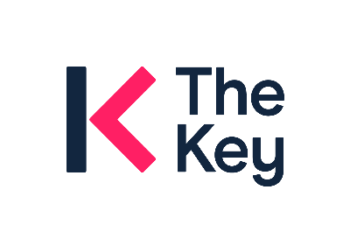**THE KEY LEADERS 2025/26**

**WOKINGHAM ‘GROUP DEAL’**

**Contact Details:** Sara Sadeeq (The Key) [sara.sadeeq@thekeysupport.com](mailto:sara.sadeeq@thekeysupport.com)

**Introduction**

* A large proportion of Wokingham schools and academies make use of ‘[The Key Leaders](https://schoolleaders.thekeysupport.com/)’ and for many years Children’s Services arranged and managed a Group Deal offering significant discounts on membership.
* The arrangements changed in April 2023 – discounts are still available, but renewals, new purchases and invoicing are all arranged directly with The Key. WBC no longer actively manages the group deal, so schools/academies don’t need to sign up for The Key via Wokingham Traded Services.

**Next steps**

* The Key have informed us that Wokingham schools/academies should receive 10% discount from their standard pricing for 2025/26.
* Where schools/academies already have The Key membership, The Key should be in touch in advance of renewal, but if you have queries, please contact Sara Sadeeq at The Key (contact details above).
* Wokingham schools/academies that haven’t previously purchased The Key are welcome to start membership. Please contact Sara Sadeeq (contact details above).
* Schools that are part of an Academy trust may wish to consider combining all of your school memberships onto one central purchase/renewal date. Please contact Emma Sterling [emma.sterling@thekeysupport.com](mailto:emma.sterling@thekeysupport.com)