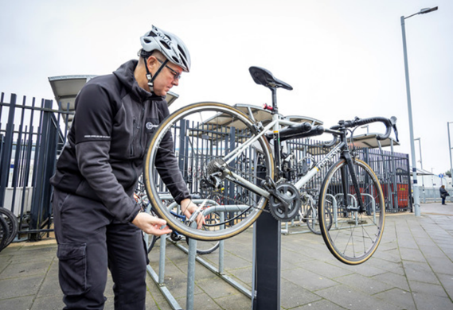

Want to learn to look after your bike?
You can now book a place on one of our basic Bike Maintenance Courses (Adults only) at the following venues:
- 8 February – Emmanuel Church Hall, Woodley
- 1 March – St Paul’s Parish Hall, Wokingham
- 8 March – Pinewood Scout Hut, Wokingham Without
- 22 March – Winnersh Community Centre, Winnersh
The course costs £11 and will cover the following topics:
- How to check your bike
- How to change an inner tube if you get a puncture
- How to adjust your brakes
- How to clean and oil your bike
You can also get general maintenance advice from our instructor. Please bring your own bike and an inner tube.

