GUIDE TO COMPLETION OF THE FORM RELATING TO:
CHANGE OF CHEQUE SIGNATORIES WITH NATWEST AND BANKLINE USERS and Profiles.

This guide is to assist schools (or WBC establishment) in completing the necessary paperwork in order to be set up as a signatory with Natwest or to have a Bankline user and profile set up for access to the online imprest account.

Please note that if you are adding additional users or signatories (i.e. without removing an equal number of people), this will be subject to agreement by the Council.

Signed completed form(s) must be returned via email to business.services@wokingham.gov.uk.

_______________________________________________________________________________________________

Summary of Updates Form
Please see the below image and match the green numbers in the explanation below to those on this image:
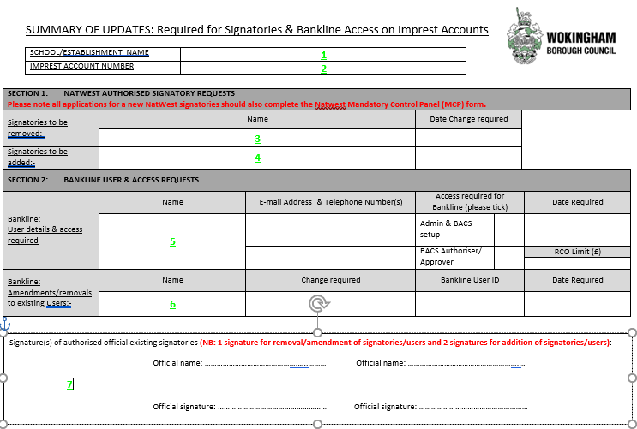

FIRST SECTION:

This is to be completed if you require new cheque Signatories & Bankline Access on Imprest Accounts.

1. SCHOOL/ESTABLISHMENT NAME: Please put the name of your school (or establishment if this is an
account for a team within the council) here.
2. IMPREST ACCOUNT NUMBER: Please put your bank account number here.

SECTION 1: NATWEST AUTHORISED SIGNATORY REQUESTS
New NatWest cheque signatories should be accompanied by the Natwest Mandatory Control Panel (MCP) form. Please refer to page 3 for guidance on this form.

3. Signatories to be removed: Name of the cheque signatory to be removed from Natwest
NB: The NatWest MCP form is not required for removals.

4. Signatories to be added: Name of the cheque signatory to be added to Natwest

The date can be a future date or just the date you are signing the form depending on when the removal or addition needs to take place.

SECTION 2: BANKLINE USER & ACCESS REQUESTS

We would recommend to the schools to have two admin users and two authorisers on Bankline. This would enable you to provide cover when required and ensure that those who upload the BACS payments are not the same as who can authorise those payments. This would meet banking audit requirements.

For clarification on the roles please see below:

The Admin profile will allow the user to view the imprest account and upload any BACS payments.
The authoriser profile will allow the use to authorise payments (not upload) and also view the imprest account.

When you are applying for either role, we would ask that you provide us with your schools Register of Certifying Officer limit for each user for BACS payments so we can upload this onto Bankline.

5. Bankline: User details & access required: In this section please enter the following is the appropriate
sections:

- Name
- E-mail Address & Telephone Number(s)
NB: Please provide email so the user can receive any re-set password requests.
- Access required for Bankline (please tick) either: BACS or Authoriser
- Date required
- Register of Certifying Officer Amount
NB: If you require more than one user to be set up please email Business Services so we can send you a multiple Bankline user form.

6. Bankline: Amendments/removals In this section please enter the following is the appropriate
to existing Users: sections:

- Name
- Change required – ie a change of profile or removal from Bankline.
- Bankline User ID
- Date required

NB: It is really important for the purposes of continuity and auditory requirements that you notify Wokingham Borough Council of any changes in personnel that may affect this process.

SIGNATORY SECTION:

7. Please arrange for authorised signatories to sign this section. See below for clarification on how many signatures are required for this form:

- If the change is removal or amendment of a signatory, one signature is required.
- If the change is adding a new signatory, 2 signatures are required.

- If the change is regarding the addition or removal of Bankline users only one signature is required.

_______________________________________________________________________________________________

Natwest Mandate Control Panel Authority Form
Please see the below image in conjunction with the following explanation for guidance on the completion of this form:

The only section that requires completion by the signatory is “Confirming your agreement”.

Complete the new signatory’s full name and official position either by typing or using black ink in BLOCK CAPITALS. The new signatory must then add their “Specimen signature” next to their name. Once completed, please scan a copy and return to Business Services using the address at the top of these instructions.

If there is more than one signatory to be added please use another line.

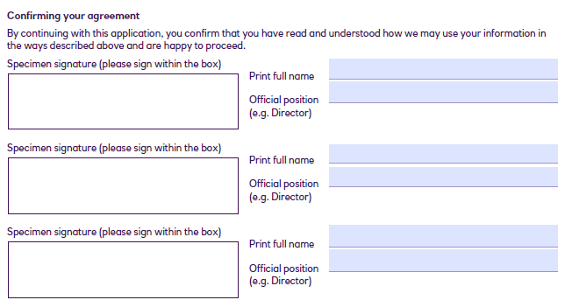

If you have any queries please contact Business Services who will be able to assist you.

