Black History Month in Wokingham schools

Throughout October, schools across the borough took part in a range of powerful and celebratory events to mark Black History Month.
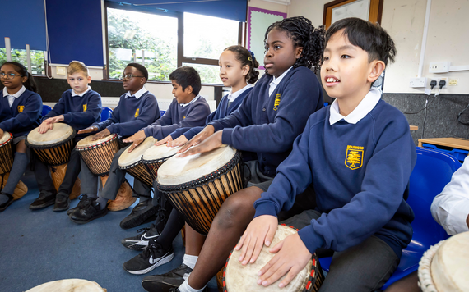

Bearwood Primary School welcomes workshops
Bearwood Primary School celebrated the theme Standing Firm in Power and Pride, with a special focus on Afro hair as a symbol of Black pride and identity.
The month of activities began with a powerful workshop from the Osun Arts Foundation, where pupils took part in African drumming, dance and storytelling, including a talk from a descendant of a Benin warrior.
Throughout Black History Month, weekly assemblies explored respect and identity.
Children with Afro hair attended break-time workshops using a professional hairdresser’s mannequin, creating space for peer support and discussion.
This year’s event also featured an international food sale, bringing the school community together in celebration.

My Hair - a poem by Salena Fenton, Year 3, Bearwood Primary School (second from right)
My hair is my crown
My hair is both my mum and dad
My hair reminds me that I come from African and Caribbean queens
My hair is curly and coily
Sometimes it’s not easy
Sometimes it hurts
But it reminds me I am strong and can do anything
My hair isn’t a pillow
Please don’t touch it
I can have braids, cornrows, twists and puffs
My hair can be everything and is everything
My hair isn’t too big
Don’t ask me to pat it down
MY AFRO IS MY CROWN

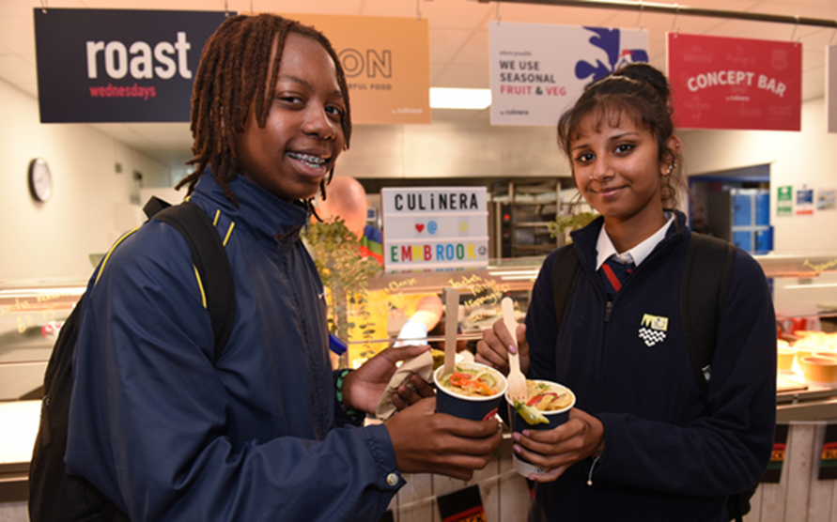

The Emmbrook School embraces cultural classics
At The Emmbrook School, students took part in lessons that explored key moments and figures from Black History, reflecting on the past, present and future. These sessions encouraged thoughtful discussion around identity, equality and the importance of recognising diverse contributions to society.
The celebrations culminated in a vibrant lunch event in the school canteen, where pupils came together to enjoy a variety of cultural dishes. The event was a great opportunity for students to experience and appreciate different culinary traditions, sparking conversations and curiosity about the cultures behind the food.

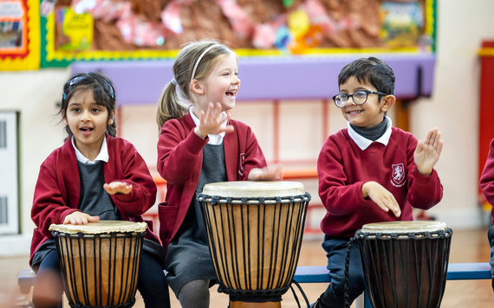

Walter Infant School pupils try African drumming
At Walter Infant School, pupils in Year 1 and 2 took part in an energetic African Drumming Workshop.
Led by a skilled instructor, the children learned traditional rhythms and had the chance to experiment with beat and tempo, creating their own vibrant sounds.
As part of their learning, pupils also explored the lives and legacies of influential Black figures including Mae Jemison and Marcus Rashford.

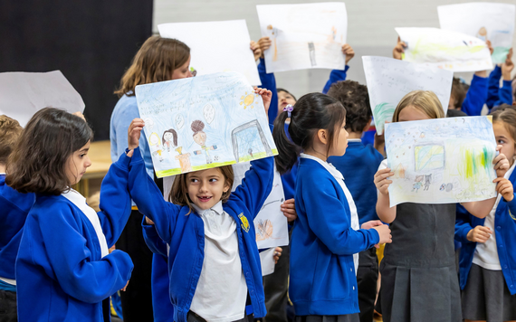

Winnersh Primary School pupils share work
Pupils from across all year groups at Winnersh Primary School came together for a vibrant sharing assembly to mark Black History Month. The event was a wonderful opportunity for students to showcase their creativity and learning.
The assembly featured a display of artwork, reflecting the pupils’ thoughtful engagement with Black History and culture.
A lively dance performance inspired by Strictly Come Dancing’s Oti Mabuse brought energy and excitement to the room, while other pupils gave powerful presentations on key historical figures such as Claudia Jones and Doreen Lawrence.
View full picture gallery of school events

