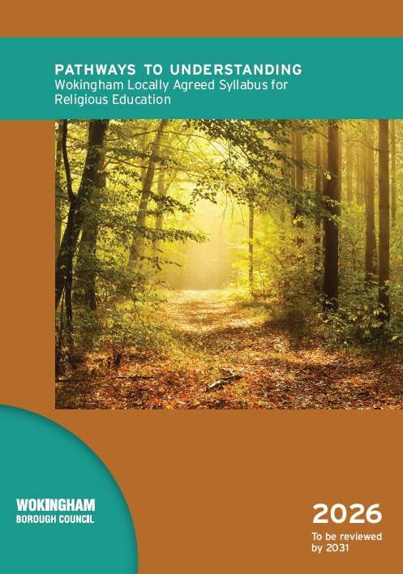
Planning Guidance for the Wokingham Agreed Syllabus for RE

14th January 2026
Ian Nicholson – National RE Adviser
EYFS -
CHRISTIANITY | SCHOOL CHOICE | NON-RELIGIOUS WORLDVIEWS | OTHER | OTHER

KEY STAGE 1 –
CHRISTIANITY | HINDU DHARMA | JUDAISM | NON-RELIGIOUS WORLDVIEWS | OTHER | OTHER

LOWER KEY STAGE 2 –
CHRISTIANITY | ISLAM | SIKHI | NON-RELIGIOUS WORLDVIEWS | OTHER | OTHER

UPPER KEY STAGE 2 –
CHRISTIANITY | HINDU DHARMA | JUDAISM | BUDDHISM | SIKHI | ISLAM | HUMANISM

EYFS

What does it mean to be kind?
Why are some people remembered by others?
Why are some places special?
Why are some occasions special?
What can we learn from stories?
Why are some items and actions special?

KEY STAGE 1
CORE QUESTIONS AT THE BEGINNING OF EACH YEAR GROUP
Year 1 – What are religions and worldviews and how do we find out about them?
Year 2 – What do different religions and worldviews have in common?
RELIGION AND WORLDVIEWS SPECIFIC QUESTIONS
CHRISTIANITY | HINDU DHARMA | JUDAISM | NON-RELIGIOUS WORLDVIEWS
- What do Christians believe about God and why?  - What is the story of Jesus and how do Christians remember him?  - What did Jesus teach his followers and how did he teach?  - How and where do different Christians worship and celebrate?  - What role does the church play in the life of a Christian?  - How and why do Christians pray? | - What beliefs and values are most important to Hindus and why?  - What role does a place of worship play in Hindu life?  - What might Hindus learn from traditional stories?  - What might a Hindu way of life look like? | - What is Judaism and where does it come from?  - What might a Jewish way of life look like?  - What important things are remembered at Shabbat and Rosh Hashanah or Pesach?  - What role does the synagogue play in Jewish life? | - How do non-religious families recognise and celebrate important events?

Exemplar Key Stage 1 Plan

Year 1
Introductory Unit | Unit 2 | Unit 3 | Unit 4 | Unit 5 | Unit 6
What are religions and worldviews and how do we find out about them? | What do Christians believe about God and why? | What is the story of Jesus and how do Christians remember Him? What role does the Church play in the life of a Christian? | What might a Jewish way of life look like? | What is the story of Jesus and how do Christians remember Him? What role does the Church play in the life of a Christian? | How do non-religious families recognise and celebrate important events?
L1 – What makes a group or a community?  L2 – Does everyone have the same view? | L3 -L8 – | L9 – L16 – | L17 – L23 – | L23 – 29 – | L30 – 36 –

Year 2
Introductory Unit | Unit 2 | Unit 3 | Unit 4 | Unit 5 | Unit 6
What do different religions and worldviews have in common? | What beliefs and values are most important to Hindus and why?  What role does a place of worship play in Hindu life? | How and where do different Christians worship and celebrate? | What did Jesus teach his followers and how did he teach? | What role does the church play in the life of a Christian?  What role does a place of worship play in Hindu life?  What role does the synagogue play in Jewish life? | What do Christians believe about God and why?  How and why do Christians pray?
L1 – To revisit what we have learned about what communities have in common and begin to explore the differences in worldviews, religions and beliefs  L2 - What are some of the shared features of religions? | L3 – L8 – | L9 - 16 – | L17 – L23 – | L24 – 30 – | L31 - 36

LOWER KEY STAGE 2
CORE QUESTIONS AT THE BEGINNING OF EACH YEAR GROUP
Year 3 – Can observing behaviour reveal what people believe and value?
Year 4 – How does reading sacred texts help people understand the beliefs and values of others?
RELIGION AND WORLDVIEWS SPECIFIC QUESTIONS
CHRISTIANITY | ISLAM | SIKHI | NON RELGIOUS WORLDVIEWS
- What do the biblical names for Jesus tell us about who Christians believe him to be?  - How did Jesus teach his followers to show friendship?  - Why is Easter important to Christians?  - What difference does Pentecost make and to whom?  - Where do ideas about right and wrong come from for Christians?  - How and why do Christians try to make a difference in the world? | - What do Muslims believe about God and why?  - Who is Prophet Muhammad and why is he important to Muslims?  - How and why is the Qur’an a source of guidance for life for a Muslim?  - What role does the Mosque play in Muslim life? | - What do Sikhs believe about God and why?  - What might it look like to live as a Sikh?  - What is the Guru Granth Sahib and why is it important to Sikhs?  - What role does the Gurdwara play in Sikh life and worship? | - How do non-religious families decide what is right and wrong?

Introductory Unit | Unit 2 | Unit 3 | Unit 4 | Unit 5 | Unit 6
Y3: Can observing behaviour reveal what people believe and value?
L1 – To identify and describe some of the links between belief and behaviour
L2 - To consider how being a part of a community influences the beliefs and actions of an individual

Introductory Unit | Unit 2 | Unit 3 | Unit 4 | Unit 5 | Unit 6
Y4: How does the study of sacred texts and stories help people learn about beliefs, values and worldviews of others?
L1 – To identify how texts and stories people read influence their view of the world and behaviour
L2 - To consider how communities use story and text to maintain their identity

UPPER KEY STAGE 2
CORE QUESTIONS AT THE BEGINNING OF EACH YEAR GROUP
Year 5 – What shapes a person’s worldview?
Year 6 – How can having faith in someone or something help people cope with matters of life and death?
RELIGION AND WORLDVIEWS SPECIFIC QUESTIONS
SIKHI OR BUDDHISM
ISLAM OR HUMANISM
THESE ARE COMPULSORY UNITS

CHRISTIANITY | HINDU DHARMA | JUDAISM | ISLAM | HUMANISM | SIKHI | BUDDHISM
- Why is the Bible important to some Christians in worship both in church and at home?  - How is the Bible interpreted by different Christians?  - How does the Bible teach Christians to be wise?  - What do different Christians believe about life after death and how do they show these beliefs?  - How and why do Christians show commitment to God?  - How do Christian beliefs influence the way people respond to local and global issues? | - How do tradition, sacred text and story help Hindus understand their relationship with the world?  - What might it look like to live as a Hindu in different parts of the world?  - What influences the way Hindus respond to local and global issues of social justice? | - What do Jews learn about God and human life from their sacred texts and traditions?  - What does it mean to live a Jewish life and how does this vary among different Jewish communities?  - What influences the way Jewish people respond to local and global issues of social justice? | - What do Muslims learn about God and human life from their sacred texts and traditions?  - What might it mean to be a Muslim in different parts of the world?  - What influences the way Muslims respond to local and global issues of social justice? | - What influences a non-religious and/or humanist response to local and global issues of social justice? | - What do Sikhs learn about God and human life from their sacred texts?  - What might it look like to live as a Sikh in different parts of the world?  - What influences the way Sikhs respond to local and global issues of social justice? | - How do sacred texts and traditions help Buddhists understand their identity and purpose?  - What might it look like to live as a Buddhist in different parts of the world?  - What influences the way Buddhists respond to local and global issues of social justice?

Introductory Unit | Unit 2 | Unit 3 | Unit 4 | Unit 5 | Unit 6
Y5: What shapes a person’s worldview?
L1 – To identify a range of factors that might influence a person’s view of the world
L2 - To consider the range of factors that influence a specific religious perspective

Introductory Unit | Unit 2 | Unit 3 | Unit 4 | Unit 5 | Unit 6
Y6: How can having faith in someone or something help people cope with matters of life and death?
L1 – To consider what the key questions of life and death might be and where answers might be found.
L2 - To explore the role that faith might play in helping answer questions that have no certain answer.

NOTES

