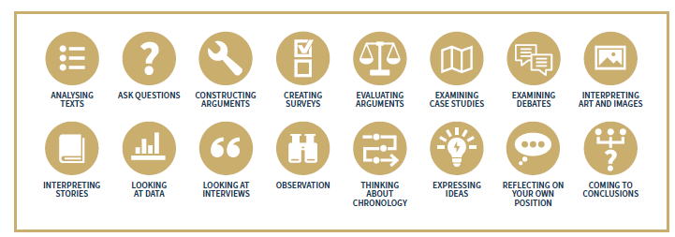

Tools and Methods for the Disciplinary Knowledge Element of RE – you will find this in the Agreed Syllabus, The Statement of Entitlement and the RE Directory

