A Level Examination Results – August 2026 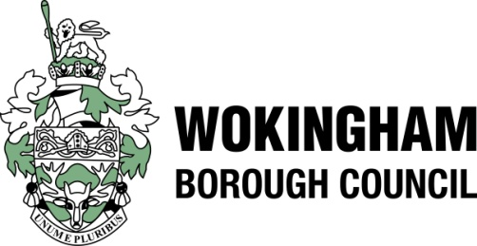

Please complete this form and submit via the Wokingham School Hub
by 11am on Thursday, 13th August 2026

School: …………………………………………………………………….

Contact Name: ……………………………………………………………..

Contact Email: ……………………………………………………………..

Contact Phone Number: ………………………………………………….
(Please do not provide the school switchboard number)

Please provide the 2026 results as below:
1 | Number of students entered for any level 3 course at the end of KS5
2 | Number of students entered for at least one A Level
3 | Number of entries at A level
4 | Number of entries for A level awarded A*- A
5 | Number of entries for A level awarded A* - B
6 | Number of entries for A level awarded A* - C
7 | Number of entries for A level awarded A* - E
8 | Average Point Score per entry as a grade at A Level

If you have any queries regarding the above, please contact as detailed below:

Smitha Vinod – 0782 792 9510 – smitha.vinod@wokingham.gov.uk
Halak Nanavaty - Halak.Nanavaty@wokingham.gov.uk
You may also contact us by email: perf.data@wokingham.gov.uk

